**Prerequisites for Winning a League**

**Karthik Garimella1, Rishave Kumar2, Dr.K.Kalaiselvi3**

*1Karthik Garimella, 2Rishave Kumar, 3*Dr. K. Kalaiselvi, Assistant Professor, Department of Computer Science and Engineering, SRM Institute of Science and Technology, Kattankulathur, Kancheepuram(D.t), Tamil Nadu, India, Email ID : kalaisek2@srmist.edu.in.

---------------------------------------------------------------------***---------------------------------------------------------------------

**Abstract -** ***Over the past decade, Data Analytics has been increasingly utilized for the purpose of predicting how a team sets itself up, how it scores goals and how it concedes goals. Many football clubs use such techniques to improve their game and play better against opposition. Data Analysis in Football helps in clubs in performing better and mitigating their deficiencies. Our research highlights how football has changed over the years i.e. which type of playing style has bestowed success upon teams.The research would exhibit many trends such as in goal scoring pattern, winning runs, expected goals for and against, etc. which will be demonstrated using regression analysis, qualitative comparison analysis, quantitative analysis, statistical analysis and radar charts. Finally, our study uncovers common themes required for a football club to win the league.***

***Key Words*: Goals, xG, PPDA, xPoints, Points per Game, Radar Chart, xGA.**

1. **INTRODUCTION**

Football is a sport that is watched by billions. This sport is worshipped all around. A symbol of hope, solidarity, love and a sport that brings people together towards a common goal. Every year, a large number of clubs from different countries play in their respective leagues for a variety of reasons. Some of them are designed to win the championship. Others are trying to avoid relegation. But the final answer to their hopes is always based on one thing: numbers, data, and statistics. You just need one more point to be good. It's a loss if you get one point less. You'll be the champion if you score one more goal. You throw away the entire season if you score one goal less or concede one goal more than the opposition. It's all about the finer points. That is a reality that every football fan is aware of. football competitions provide coaches and experts with excellent visual content.

It is an obvious chance for players to demonstrate their talent and worth at competitions such as the World Cup, EURO Championships, Champions League, or Europa League. The application values of research findings enable teams to focus on the flaws that can make or break a team.. Despite the fact that many tournament officials provide data, scientific papers on various season analysis of at least league competitions are scarce. The large database relating to passing numbers, set pieces, and objectives is a disadvantage of the listed method of study. Our literature review revealed only a few articles on the league analysis of the top leagues in Europe. The primary aim of football players is to score as goals and not concede. Effective offensive actions and finishing momentum is very often a training session aim for many coaches. There are only few works which analyze ball placement and scoring chronology appear that is rarely seen.

Pressing (PPDA) is a new metric in football that has not been used much in the Data Analysis of Football but it is one of the holy grails of football at this point as it helps in determining how much a team presses the the opposition to regain possession of the ball in higher areas of the pitch which can increase the probability of the team to score a goal. PPDA ( Passes per Defensive Action) is the official term for pressing and which is used to measure the pressing factor of a team. PPDA denotes the amount of passes made by the opposition which is allowed by the team before regaining possession of the ball. The lower the PPDA , the higher the pressing. The reason why PPDA is important is because it provides a new spectrum to understand why teams are scoring more goals than ever. Generally, it is the teams with lower PPDA value that win the match but this is not always true. PPDA is a fascinating metric to help in understanding how dominant the title winning teams are on the ball and how adamant they are in retaining possession.

Expected Goals (xG) measures the probability of a shot taken to result in a goal using several factors such as whether it was a headed shot or whether it was a long range shot, etc. The probability of a penalty to result in a goal is 0.76 as 76% of all penalty kicks leading to goals. So, if the team’s xG is pretty high and their goals scored is pretty low, it means that the team is underperforming their xG and their shot conversion is low. So xG plays a big role in defining if a team is efficient in scoring or not. xGA (expected goals against) is a metric that gives the xG of the opponent

All these metrics guide to another new metric called xPoints (Expected Points) which take all the shots taken, goals conceded, xG, PPDA, etc. into account to calculate the expected points that were accumulated and by how much did the title winning team overperform or underperform.

1. **RELATED WORK**

Various models have estimated probability of winning home matches or away matches Chances of winning home matches with higher advantage than Away matches which concludes home advantage does play a significant role while playing.

Real time analysis has defined the improvement in training and positional data sets that completely transform the approach in football from training to tactical formation .

Several models also talk about competitive imbalance especially in the English premier League due to financial gaps between the teams and this competitive imbalance is been increasing over recent year last year Manchester city got banned from champions league by the uefa’s financial fair play rules but the ban got lifted later but there is no denying that there is huge difference between top tier (the big six) and the rest of the league teams.

Factor analysis on the attacking and defensive styles of play this paper defines and differentiates between the styles of play and how effective it is,As the football as progressed through many years many philosophy and trends on how to play attacking or defensive positional, possession play have changed over the years italian football is well known for its solid defensive structure and Dutch is known for its possession based attacking football.

Goal scoring analysis on how many and the process of goal scoring occurs. The aim of the work was multilevel goals analysis which were scored in 380 matches of English Premier League in 2008/2009 season. The paper found that during the 2008/2009 season in English Premier League shot placement was different with penalty area advantage at 85.1% and 24.7% (goal area). The most competitive foreign teams end the majority of their offensive attacks in the penalty area, which may mean a well-honed positional and counter-attack strategy. The majority of goals (69.3%) were scored without the ball being intercepted, which may mean that this form of shot supposedly surprises goalkeepers or at the very least gives them little time to respond. Just 12.8 percent of goals were scored after dribbling, owing to modern players' lack of room and inability to maintain long contact with the ball.

This study is also based on the offensive actions of the goal scoring in the european elite football which concludes that 1 out of every 4 goals scored is set piece action in open plays collective or team goal consist of half 50% of the goals scored whereas individual brilliance has produce only 1 out of 10 goals scored ball carrying, dribbling does not contribute so much goals but great to look at.

Positional analysis of entries into the opposition penalty box can be a key factor into winning and losing When losing by 1,2 or more than 2 goals, teams had significantly lesser entries into the penalty area than those winning team. More entries into the box suggest that the team has more attacking threat and higher probability to score as scoring from long distances is rarity and does not happen too often .

The findings of the Analysis of Goal Scoring Patterns in the 2018 FIFA World Cup revealed that the majority of goals were scored in the second half of the game, with the first 15 minutes of the second half and the final phase of the game seeing the most goals conceded. In comparison to the first and middle thirds, the final third produced the majority of goals.

The study's key finding is that in European football, the number of goals scored is higher in the second half, with the scoring rate being higher in the final 15 minutes than the rest of the game. There were no gaps between the three consecutive seasons and four European leagues after analysing eleven thousand goals..This means that the scoring trends aren't affected by the season or league. The production of exhaustion during a match is one of the factors that could play a role.

1. **PROPOSED WORK**

Data collected from Football-data.co.uk and understat.com would give complete implementation benefit using new metrics. The objective of the proposed work is to find patterns in 5 consecutive seasons in the EPL. The objective is to use newer metrics in football to help in analysing the already data driven sport to a higher extent. xG and PPDA are the main driving force of the proposed work to assist in achieving deeper analysis on how teams are performing and if this performance is sustainable and how has football progressed over the last 5 years.

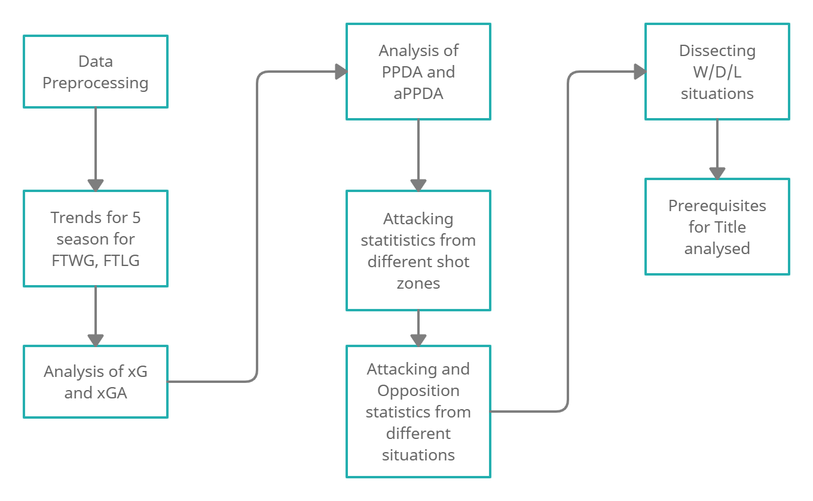

Architecture Diagram [1.1]

We want to compare the seasons of all title winners from the 2015/2016 season to the 2019/2020 season. The comparisons start from how those teams scored throughout the season with what consistency. How they performed according to their xG with respect to their goals scored. Comparison on how the teams conceded goals and how the teams played with respect to their xGA. Every title winning team needs to win the most number of games and lose the least but how do those numbers fare in those 5 seasons?

The title winning teams evidently put up the best numbers in comparison with every team in the league. What kind of style do these teams deploy and how many of their goals are reliant on them using the system. How reliant are these teams on set pieces, corners, penalties and open play. What kind of relevance does PPDA play when those certain systems are utilized, what kind of advantage does that system offer those teams?

Did the teams overform their xG or xGA? Did they rely more on pressing, possession or counter attack? In how many games did they have more xG than their opponents? Did the teams have lesser PPDA than their counterparts and if they did, then in how many games? How did the teams perform when they won, drew or lost the game? What kind of winning run did the clubs go on? All these questions proposed and analysis on them can provide evidence on how teams fared throughout the season in their title run.

1. **RESULTS AND DISCUSSIONS**

The objective of proposed work is to find a consensus on what are the necessary preconditions to win the league of 38 matches in a season. Thus analysing every season from 2015/2016 to 2019/2020 becomes mandatory to find the similarities and distinction in every season to get a general consensus on how teams have played, which formations they have used, which playing style they found successful.

**Leicester City 2015/2016**

Leicester City had a 5000/1 odds to win the PL title. Leicester City had hired a new manager for this season named Claudio Ranieri. Their most used formation was 4-4-2 in which they used this formation for a total of 2974 minutes in the league. This formation was used for 83% of that total time in the league. They scored 60 of their 68 goals while using this formation. Leicester City had attempted 373 shots in open play which resulted in 47 goals. They had an xG of 49.09 from those 373 shots. Leicester City underperformed in their xG from open play. They had 88 attempts from corners in which only 5 were converted which had an xG of 9.73. 33 attempts from set pieces of which 6 were converted. Leicester City had 13 attempts from the penalty spot of which 10 were converted and 3 were missed having a combined xG of 9.9. In total, Leicester City scored 68 goals from a combined xG of 68.42 which denotes that Leicester City performed accordingly to their xG. But this does not mean Leicester City performed correspondingly to their xG in every game.

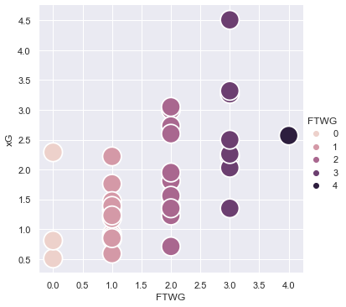

How Leicester City scored with respect to their xG [2.1]

The image above shows that in some games Leicester City overperformed their xG. In a game where Leicester City scored 4 goals, they only had an xG of 2.57. In some games, they underperformed their xG as well. For instance, Leicester City did not score any goals but had an xG of 2.29. Leicester City had positive (+ve) xG in 29 games and negative (-ve) xG in 9 games. In those 9 games with negative xG, 4 games resulted in a draw, 2 in a win and 3 in a loss. These games profited Leicester City with 10 points which were the difference in them winning the title 10 points clear of all opposition. Overall, this proves that Leicester City had matches where they had more xG than goals and vice versa as well. But the overall xG and goals scored ratio was maintained stating that they did not overperform or underperform their xG all in all.

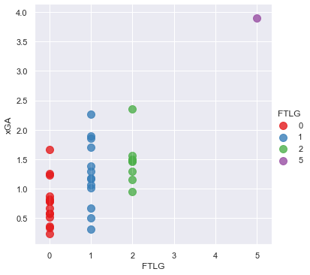

How Leicester City conceded with respect to their xGA [2.2]

Leicester City had conceded 36 goals from a total of 45.02 xG. Leicester City conceded 379 shots from open play which led to 23 goals. Those 379 shots had a combined xG of 30.6. The xGD (Expected Goal Difference) in open play is 18.49. The opposition had 88 attempts from corners of which 7 were converted of which the opposition had an xG of 9.73. The xGD of corners is -2.6 meaning the opposition had better chances of scoring goals from corners which shows as Leicester City conceded more goals from corners than they scored from corners. Leicester City conceded 4 penalties of which all were converted. Leicester had a combined xGA of 45.02 but only conceded 36 goals which reveal that the opposition were wasteful in front of the goal against Leicester City or the Leicester City players made blocks and the keeper made substantial saves to keep the number of goals conceded lower than xG.

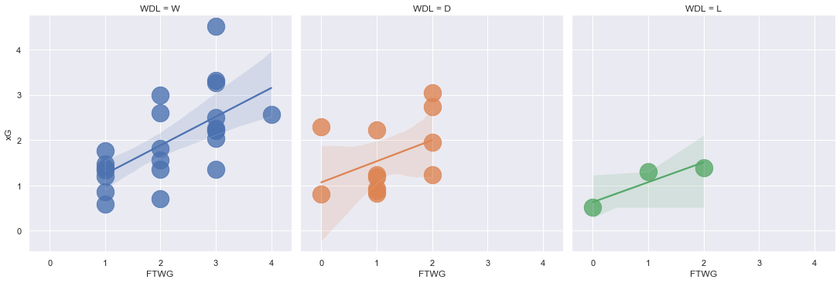

Performance of xG and xGA when Leicester City won,drew or lost [2.3]

In the 38 games season, Leicester City won 23, drew 12 and lost 3 which led them to gain 81 points in the end. Leicester City never won more than 5 games in a row as they drew many games in the season. In a run of 16 games, they won 11 games, drew 4 and lost 1. Leicester City were deployed in a 4-4-2 formation which focused more on the defensive structure of the team with the onus on the forwards to score on the counter attack. Leicester City were awarded 13 penalties of which 10 were scored which amounts to 14.7% of their total goal tally. The amount of penalties won is high in an average season. The reason behind this is the amount of counter attacks that took place which increased the amount of entries into the penalty box at a high pace which forced the opponents to concede the fouls and ultimately a penalty. Leicester City had 187 shots from out of the box which resulted in 3 goals with an xG of 6.17, 289 shots in the penalty area resulting in 54 goals with an xG of 46.8, 46 shots in the six-yard box leading to 10 goals with an xG of 16.48. These stats display how efficient Leicester City were in the penalty box.

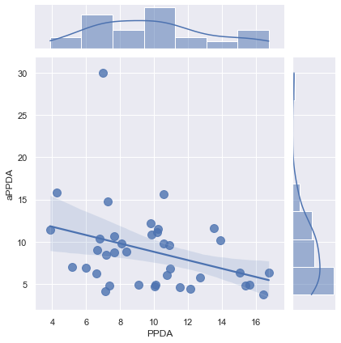

PDDA and aPPDA of Leicester City [2.4]

Leicester City relied mostly on counter attacks for their goals which did not force an emphasis on retaining possession or catching opposition in their own half to create chances for scoring goals. Hence, the PPDA statistics do not exhibit the true nature of their play. Leicester City had negative PPDA in 18 games and positive PPDA in the other 20. The expected points for Leicester City was 68.94 while they gained 81 points at the end of the season. Leicester City had 2.13 points per game. Leicester City acquired 12 more points than the expected points as this metric is dependent on the xG and xGA of each and every game. To conclude Leicester City's season, the team overperformed in the category of scoring goals from inside the penalty box and did not concede goals from high xG situations which can display overperformance in their overall season.

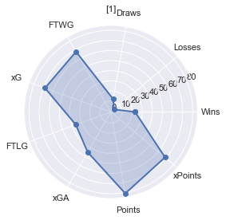

Radar Chart of Leicester City 2015/2016 [2.5]

**Chelsea 2016/2017**

Chelsea had just hired a new manager in Antonio Conte. The most used formation for Chelsea was 3-5-2 which was used for a total of 1919 minutes and 3-4-2-1 for 912 minutes. 3-5-2 and 3-4-2-1 are almost the same formation with the only difference coming in the midfield which includes 4 players in the 3-4-2-1 formation rather than 5 players in the 3-5-2 formation. Both these formations were used 82.7% of the total time played in the league. They scored 74 of the 85 goals in these two formations. Chelsea had attempted 421 shots in open play and scored 61 with the xG for those goals being 46.63. Chelsea overperformed massively in this department as they scored 20 goals more than probability of their shots leading to a goal. They had 90 attempts from corners of which 13 led to goals with an xG of 8.75. They had 35 attempts from direct freekicks scoring 3 with an xG of 2.1 for those free kicks. 32 attempts from set pieces scoring 6 with an xG of 3.89. They earned only 4 penalties and scored on;y 2 which had an xG of 3.04. Chelseas scored 85 goals from an xG of 61.8 which denotes that they scored 23 more goals than expected. This overperformance resulted in 23 more goals which in turn earned Chelseas the title.

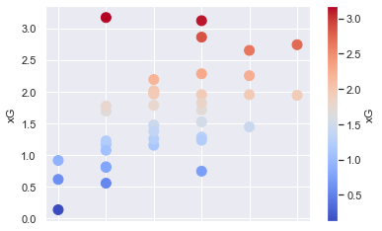

How Chelsea scored with respect to their xG [3.1]

Chelsea scored 4 goals in a game where they had 1.95 xG. Chelsea scored only 1 goal where they had 3.17 xG. Every team can have off days and so did Chelsea in that particular game. Chelsea had started the campaign a bit poorly but after the 3-0 loss to Arsenal, they changed their formation to 3-5-2 which started a streak of wins. Chelsea had positive xG in 30 matches and negative xG in 8 matches. In those 8 matches with negative xG, Chelsea won 2 matches, drew 2 matches and lost 4 matches. Chelsea overall had over performed immensely in front of goal as they had a 23.2 surge on their xG.

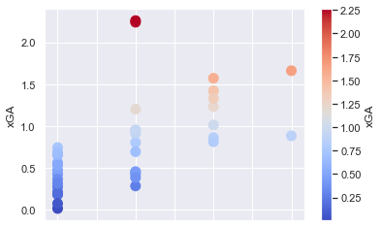

How Chelsea conceded with respect to their xGA [3.2]

Chelsea had conceded 33 goals from an overall xGA of 28.62. Chelsea conceded 24 goals from open play with an xG of 20.35 where they had a 26.29 xGD. They conceded only 2 goals from corners with an xGA of 3.89 having 4.87 xGD. They only conceded 1 goal from free kicks and 6 goals from set pieces with an xGA of 1.39 and 2.57 respectively. They conceded 2 goals from the penalty spot. Chelsea conceded more goals than they were expected to. It’s because Chelsea were defensively resolute and did not allow a myriad of clear cut chances. Hence the opponents had to shoot from distance or from at least from the edge of the box. 26 of the goals the opponents scored came from inside the penalty area but not from the six-yard box from where only 2 goals were scored.

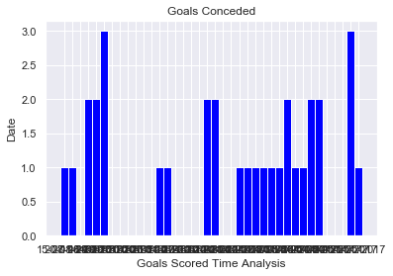

How Chelsea conceded throughout the season [3.3]

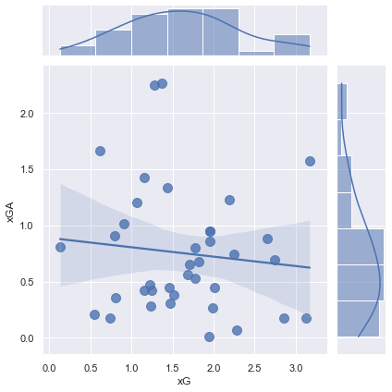

Chelsea xG vs xGA [3.4]

In 38 games, Chelsea won 30 games, drew 3 and lost 5 which helped them gain 90 points in total. Chelsea went on a 13 game winning streak from 01-10-2016 to 31-12-2016. Chelsea played a 3-5-2 formation in which the emphasis was on defensive solidity with the wing backs helping in attack as well as in defense. Chelsea scored 13 goals from corners which is 15% of the total goals scored. Chelsea had scored goals most of the goals on the counter attack with the wing backs moving forward to attack which gave Chelsea extra men in the box to be on the receiving end of crosses. Chelsea had scored 57 goals in the penalty box with an xG of 43.51. Chelsea scored 14 goals from inside the six-yard box with an xG of 10.6. They scored 12 goals from outside the box with an xG of 8.32. Chelsea were extremely efficient in the goal scoring as were the opponents when Chelsea conceded. Chelsea restricted the opposition from creating clear cut chances and the opponents had to resort to scoring from distance even though many of the goals scored were from inside the penalty box.

Chelsea had positive xG in 18 games and negative xG in 20 games. Chelsea had 2.44 points per game. Chelsea like Leicester City relied on counter attack and did not stress on possession and allowed the opposition to keep possession. Chelsea’s expected points was 75.74 but they ended up on 93 points which is 17 more than they should’ve ended up with. To conclude Chelsea’s season, they overperformed in the domain of scoring goals extraordinarily and conceded limited goals which helped them secure the title.

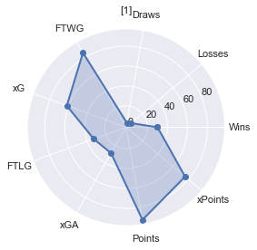

Radar Chart of Chelsea 2016/2017 [3.5]

**Manchester City 2017/2018**

Manchester City won the title with most points in the PL era. Their most used formation was 4-3-3 in which they used this formation for a total of 2881 minutes in the league. This formation was used for 84.2% of that total time in the league. They scored 85 of their 106 goals while using this formation. Manchester City had attempted 512 shots in open play which resulted in 85 goals. They had an xG of 76.12 from those 512 shots. Manchester City overperformed in their xG from open play. They had 95 attempts from corners in which 10 were converted which had an xG of 8.95. 21 attempts from set pieces of which 4 were converted. Manchester City had 8 attempts from the penalty spot of which 6 were converted and 2 were missed having a combined xG of 6.09. In total, Manchester City scored 106 goals from a combined xG of 91.43 which denotes that Manchester City performed a bit over their xG. But this does not mean Manchester City overperformed correspondingly to their xG in every game.

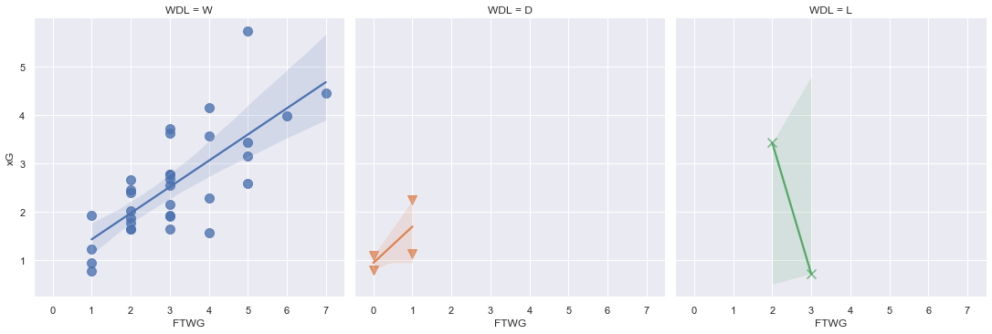

How Manchester City scored with respect to their xG when they won,drew or lost [4.1]

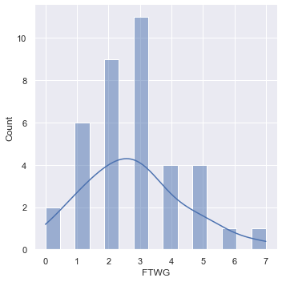

Frequency of Manchester City Goals Scored [4.2]

The image 4.2 above shows that in some games Manchester City overperformed their xG. In a game where Manchester City scored 7 goals, they only had an xG of 4.45. In some games, they underperformed their xG as well. For instance, Manchester City scored only 1 goal but had an xG of 2.25. Manchester City had positive (+ve) xG in 36 games and negative (-ve) xG in 2 games. In those 2 games with negative xG, 1 game resulted in a draw and the other in a loss. These games did not have any significant impact in Manchester City’s season. This displays how dominant Manchester City were in the 2017/2018 season regarding the xG statistic.The overall xG was lower than the goals scored.

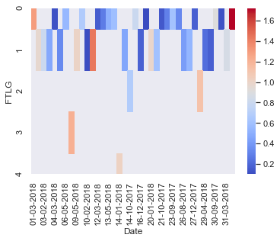

How Manchester City conceded with respect to their xGA [4.3]

Manchester City had conceded 27 goals from a total of 24.51 xG. Manchester City conceded 160 shots from open play which led to 23 goals. Those 160 shots had a combined xG of 18.31. The xGD in open play is 57.81. The opposition had 37 attempts from corners of which 2 were converted of which the opposition had an xG of 4.13. The xGD of corners is 4.82 meaning Manchester City were dominant in the air in defense and attack while corners were taken. Manchester City conceded 2 penalties of which none were converted. Manchester City had a combined xGA of 24.51 but conceded 27 goals which reveal that the opposition were pretty efficient in front of the goal against Manchester City or the Manchester City players made some errors when playing out from the back.

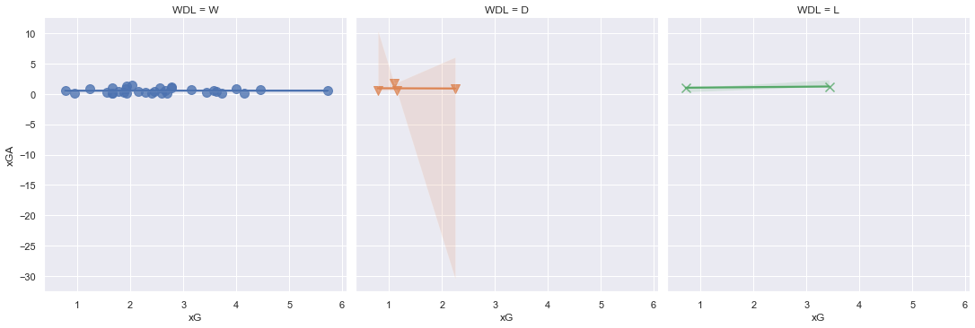

xG vs xGA in W/D/L situations [4.4]

In the 38 games season, Manchester City won 32 , drew 4 and lost 2 which led them to gain 100 points which is a PL record. Manchester City went on an 18 game winning streak which came to an end after a draw with Crystal Palace. In a run of 23 games, they won 21 games, drew 1 and lost 1. Manchester City were deployed in a 4-3-3 formation which had put its focus on retaining possession higher up the pitch instantly. Manchester City scored 80% of their goals from open play which shows they were not reliant on set pieces or penalties to score which conveys their good chance creation. The reason behind this are the quality players and the onus in retaining possession by pressing high up to pitch to regain possession by forcing the opposition to commit mistakes. Manchester City had 252 shots from out of the box which resulted in 13 goals with an xG of 8.65, 355 shots in the penalty area resulting in 64 goals with an xG of 58.75, 56 shots in the six-yard box leading to 26 goals with an xG of 25.75. These stats display how efficient Manchester City were in the penalty box.

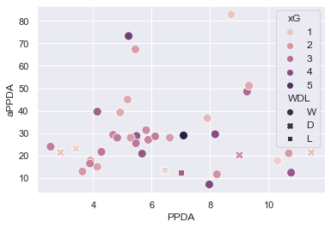

PPDA vs aPPDA in W/D/L situations [4.5]

Manchester City pressed constantly and always had more possession than the opponents in every game. Hence, the PPDA statistics come into play in this season as it shows how relentless Manchester City were during this season. Manchester City had negative PPDA in 37 games and positive PPDA in only 1. The expected points for Manchester City was 91.09 while they gained 100 points at the end of the season. Manchester City had 2.63 points per game. Manchester City acquired 9 more points than the expected points as this metric is dependent on the xG and xGA of each and every game. To conclude Manchester City's season, the team overperformed in the category of scoring goals from outside the penalty box and in the penalty box as well. Manchester City were defensively sound and played a high pressing game. Manchester City’s season is the epitome of the almost perfect season.

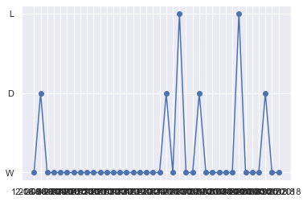

W/D/L record of Manchester City showing their 18 game winning run [4.6]

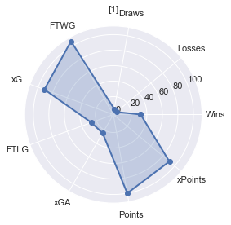

Radar Chart of Manchester City 2017/2018 [4.7]

**Manchester City 2018/2019**

Manchester City were the only team to retain the title in 8 years. Their most used formation was 4-3-3 again in which they used this formation for a total of 2816 minutes in the league. This formation was used for 82.3% of that total time in the league. They scored 75 of their 95 goals while using this formation. Manchester City had attempted 536 shots in open play which resulted in 80 goals. They had an xG of 82.13 from those 536 shots. Manchester City underperformed in their xG from open play unlike last season. They had 101 attempts from corners in which 6 were converted which had an xG of 7.63. 25 attempts from set pieces of which 4 were converted. Manchester City had 4 attempts from the penalty spot of which 3 were converted and 1 was missed having a combined xG of 3.04. In total, Manchester City scored 95 goals from a combined xG of 93.72 which denotes that Manchester City performed almost according to their xG. But this does not mean Manchester City performed correspondingly to their xG in every game.

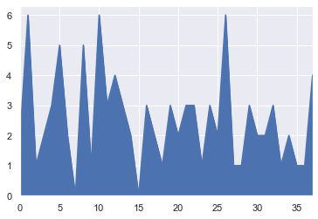

How Manchester City scored in the season [5.1]

Manchester City scored 4 goals in a game where they had 0.83 xG. Manchester City scored only 1 goal where they had 3.68 xG. Every team can have off days and so did Manchester City in that particular game. Manchester City had started the campaign in the same manner as in the 2017/2018 season but they had a slump in between the season which led to a tight title race between Manchester City and Liverpool. Manchester City had positive xG in 35 matches and negative xG in 2 matches and null xG in 1 match. In those 3 matches with negative and null xG, Manchester City won 2 matches and lost 1 match. Manchester City overall had performed similarly to their xG which showed that the over reliance on shots leading to goals had decreased.

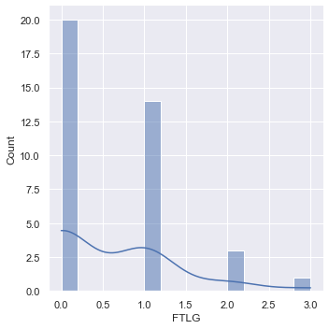

Frequency of Manchester City’s conceded goals [5.2]

Manchester City had conceded 23 goals from an overall xGA of 25.73. Manchester City conceded 11 goals from open play with an xG of 17.16 where they had a 64.97 xGD. They conceded 5 goals from corners with an xGA of 3.49 having 4.14 xGD. They only conceded 1 goal from free kicks and 2 goals from set pieces with an xGA of 0.77 and 2.92 respectively. They conceded 4 goals from the penalty spot. Manchester City conceded fewer goals than they were expected to. It’s because Manchester City were defensively resolute and did not allow a myriad of clear cut chances. Hence the opponents had to shoot from distance or from at least from the edge of the box. Manchester City were even better this season with respect to last season in terms of defending.

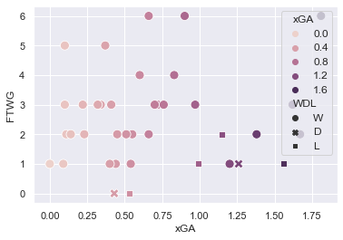

Radar Chart of Leicester City 2015/2016 [5.3]

In 38 games, Manchester City won 32 games, drew 2 and lost 4 which helped them gain 98 points in total. Manchester City went on a 14 game winning streak from at the business end of the season. Manchester City were deployed in a 4-3-3 formation which had put its focus on retaining possession higher up the pitch instantly. Manchester City scored 80 goals from open play which is 84% of the total goals scored which exhibits minimum reliance on set pieces or penalties. Manchester City had scored most of the goals in open play by retaining possession quickly with the wing backs moving forward to attack which gave Manchester City extra men in the box to be on the receiving end of crosses. Manchester City had scored 56 goals in the penalty box with an xG of 60.18. Manchester City scored 20 goals from inside the six-yard box with an xG of 26.26. They scored 15 goals from outside the box with an xG of 8.6. Manchester City were efficient in the goal scoring department without overperforming as the opponents also were fairly efficient with their chances. Manchester City restricted the opposition from creating clear cut chances and the opponents had to resort to scoring from distance even though many of the goals scored were from inside the penalty box.

Manchester City had 2.57 points per game. Manchester City pressed constantly and always had more possession than the opponents in every game. Manchester City’s expected points was 90.64 but they ended up on 98 points which is 8 more than they should’ve ended up with. To conclude Manchester City’s season, they performed accurately in the domain of scoring goals and conceded limited goals which helped them secure the title.

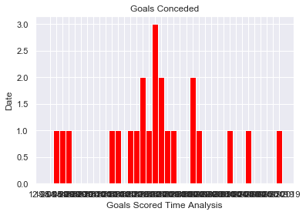

Goals Conceded over a season by Manchester City [5.4]

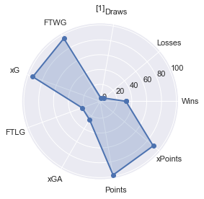

Radar Chart of Manchester City 2018/2019 [5.5]

**Liverpool 2019/2020**

Liverpool won the title with 2nd most points in the PL era. Their most used formation was 4-3-3 in which they used this formation for a total of 3166 minutes in the league. This formation was used for 92.57% of that total time in the league. They scored 75 of their 85 goals while using this formation. Liverpool had attempted 456 shots in open play which resulted in 63 goals. They had an xG of 62.03 from those 456 shots. Liverpool performed similar to their xG from open play. They had 86 attempts from corners in which 11 were converted which had an xG of 7.83. 27 attempts from set pieces of which 4 were converted. Liverpool had 5 attempts from the penalty spot of which all 5 were converted having a combined xG of 3.81. In total, Liverpool scored 85 goals from a combined xG of 75.19 which denotes that Liverpool overperformed their xG. But this does not mean Liverpool overperformed correspondingly to their xG in every game.

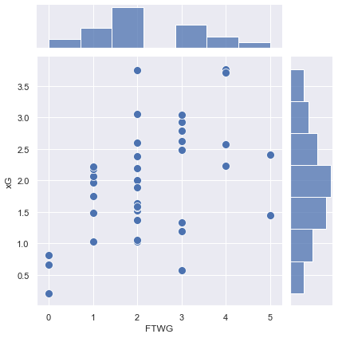

How Liverpool scored with respect to their xG [6.1]

The image 5.1 above shows that in some games Liverpool overperformed their xG. In a game where Liverpool scored 5 goals, they only had an xG of 1.45. In some games, they underperformed their xG as well. For instance, Liverpool scored only 2 goals but had an xG of 3.75. Liverpool had positive (+ve) xG in 31 games and negative (-ve) xG in 6 games and null xG in 1 game. In those 6 games with negative xG, 5 games resulted in a win and the other in a loss. These games did have a significant impact in Liverpool’s season. This displays how Liverpool overperformed in the 2019/2020 season regarding the xG statistic.The overall xG was lower than the goals scored.

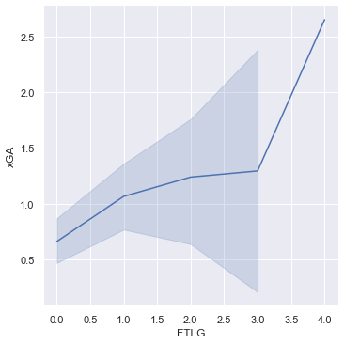

How Liverpool conceded with respect to their xGA [6.2]

Liverpool had conceded 33 goals from a total of 39.57 xGA. Liverpool conceded 268 shots from open play which led to 26 goals. Those 268 shots had a combined xG of 33.17. The xGD in open play is 28.86 but the difference in goals was 37. The opposition had 53 attempts from corners of which 2 were converted of which the opposition had an xG of 4.84. The xGD of corners is 2.99 meaning Liverpool were dominant in the air in defense and attack while corners were taken. Liverpool conceded 1 penalty of which the one was converted. Liverpool had a combined xGA of 39.57 but conceded 33 goals which reveal that the opposition were wasteful in front of the goal against Liverpool which helped Liverpool greatly in winning games that had close margins.

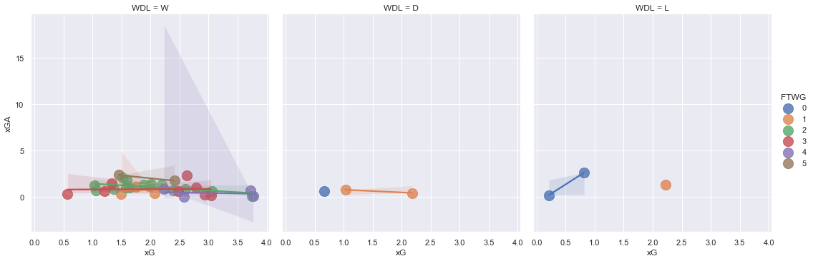

xG vs xGA in W/D/L situations [6.3]

In the 38 games season, Liverpool won 32 , drew 3 and lost 3 which led them to gain 99 points. Liverpool went on a 18 game streak which came to an end after a loss against Watford. In a run of 27 games, they won 26 games and drew 1. Liverpool were deployed in a 4-3-3 formation which had put its focus on retaining possession higher up the pitch instantly. Liverpool played with the ‘gegenpressing’ philosophy which means counter pressing in German. Liverpool pressed high up the pitch, retained possession and were a great threat on the counter. Liverpool scored 74% of their goals from open play which shows they were not reliant on set pieces or penalties to score which conveys their good chance creation. The reason behind this are the quality players and the onus in retaining possession by pressing high up to pitch to regain possession by forcing the opposition to commit mistakes and counter attacking whenever the opportunity arrived. Liverpool had 173 shots from out of the box which resulted in 12 goals with an xG of 6.54, 376 shots in the penalty area resulting in 60 goals with an xG of 51.63, 42 shots in the six-yard box leading to 11 goals with an xG of 18.01. These stats display how extremely efficient Liverpool were in the penalty box and from outside the box.

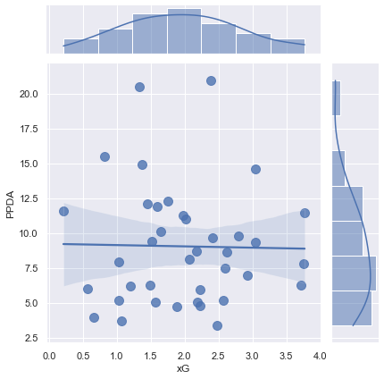

Relation of PPDA and xG [6.4]

Liverpool pressed relentlessly and always had more possession than the opponents in almost every game. The PPDA statistics come into play in this season as it shows how relentless Liverpool were during this season regarding possession retention. Liverpool had negative PPDA in 35 games and positive PPDA in only 3. The expected points for Liverpool was 74.28 while they gained 99 points at the end of the season which is plenty greater than the probable points Liverpool were supposed to earn. Liverpool had 2.60 points per game. Liverpool acquired 24.72 more points than the expected points as this metric is dependent on the xG and xGA of each and every game. To conclude Liverpool's season, the team overperformed in the category of scoring goals from outside the penalty box and in the penalty box as well. Liverpool were defensively sound with the opponents not taking their chances against them. Liverpool always played a high pressing game with the full backs setting records for most goal contributions by full backs in a PL season. Liverpool’s season was drastically different to what a normal PL title winning squad would be as the overperformance in the goal scoring department is really reliant on the scorers being overly efficient which is not sustainable and cannot be replicated every season.

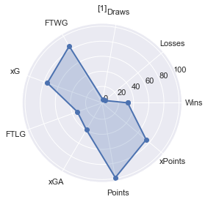

Radar Chart of Liverpool [6.5]

1. **CONCLUSIONS**

The title winning teams have resorted to the same playing style be it gegenpressing, counter attack or possession throughout the season. There have been performances that are unsustainable in the long run which shows how teams fell off the next season. Only Manchester City were able to retain the title in those 5 years. The average goals scored over 5 seasons is 87.8 and per match is 2.304. The average goals conceded is 30.4 and per match over 5 seasons is 0.799. The average xG over 5 seasons per match is 2.038 and the average xGA is 0.837. The prerequisites for winning a title not only depends on producing the numbers, playing a certain style of football, having quality players but also on teams overperforming in the department of scoring goals with regards to their xG or conceding with regards to their xGA. The persistence on PPDA has increased since the 2017/2018 season which has given an edge to the teams on dominating possession, pressing in the opponent’s half to force mistakes so that offensive advantage can be taken. Almost every team that has won the title has gained more points than the Expected Points which can show the overperformance in some department of the game. All title winning teams went on consecutive winning runs which helps in steaming away from the competition. Winning 30 games in a season seems to be the prerequisite with the number of losses wavering between 3 or 4 in a season. Drawing games have been rare because the teams have performed exceptionally winning games that turn games into wins. There is no demand for having high xG in every game as clinical efficiency in front of goal is an obligation in such games. The defensive structure has to be solid as conceding more than 0.799 goals per match can eliminate possibilities of winning the title. There is an imperative for teams to have certain players playing at the top level throughout the whole season. This is vital in terms of scoring goals and defending the goal.

**FUTURE DIRECTIONS**

Future work can include analysis on player performance, newer metrics to be used that are being introduced in the game by StatsBomb, real time analysis to improve positional play. This analysis can help us in setting up teams' detailed analysis of every player or team of passing and defending further trends will reveal in-depth metrics which can help in understanding chance creation, ball receipts in space, finding space in low blocks, line breaking passes, passing lanes, defenders bypassed by every pass,etc.

**REFERENCES**

1. Patrice Marek and František Vávra. MathSport International 2017 Conference Proceedings.
2. Memmert D , Rein R. Dtsch Z Sportmed. 2018; 69: 65-72.

[3] Roger Penn & Damon Berridge., European Journal for Sport and Society, DOI: 10.1080/16138171.2019.1577329

[4] Javier Fernandez-Navarro, Luis Fraduab , Asier Zubillagac , Paul R. Forda and Allistair P. McRoberta. 17 March 2016, Journal of Sports Sciences

[5] Krzysztof Durlik , Paweł Bieniek. May,2014,Journal of Health Sciences.

[6] González-Ródenas, J., López-Bondia, I., Aranda-Malavés, R., Tudela, A., Sanz-Ramírez, E., & Aranda, R. (2020). Technical, tactical and spatial indicators related to goal scoring in European elite soccer. Journal of Human Sport and Exercise, 15(1), 186-201. doi:<https://doi.org/10.14198/jhse.2020.151.17>

[7] Yiannakos, A., Armatas, V. International Journal of Performance Analysis in Sport · June 2006 DOI: 10.1080/24748668.2006.11868366

[8] Carlos Ruiz-Ruiz , Luis Fradua , Ángel Fernández-GarcÍa & Asier Zubillaga (2013) Analysis of entries into the penalty area as a performance indicator in soccer, European Journal of Sport Science, 13:3, 241-248, DOI: 10.1080/17461391.2011.606834

[9] Giampietro Alberti , F. Marcello Iaia , Enrico Arcelli , Luca Cavaggioni , Ermanno Rampinini.Sport Sci Health (2013) 9:151-153 DOI 10.1007/s11332-013-0154-9

[10] Alliance Kubayi. Published online 2020 Jan 31. doi: 10.2478/hukin-2019-0084

[11] P. D. Jones, N. James and S. D. Mellalieu.n International Journal of Performance Analysis in Sport · August 2004